**Experiment No:** 02

**Experiment name:**  Some basic commands in Linux Mint.

**Advantages:**

* Increase Skills.
* Getting to the Command Line.
* Industry uses of Linux, Cloud Computing and Virtualization.
* To provide an introduction in Linux environment.

**Experiment:**

Start the Terminal (Applications­>Accessories­>Terminal).Issue the following basic commands and observe the output:  
$ whoami: It shows who logged on this system  
$ hostname: It tells on which machine you are  
$ pwd: shows the path of current working directory  
$ ls : displays the list of files in the current working directory.

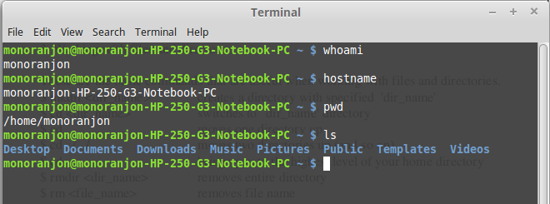

Working with files and directorie

These are the basic commands that are useful when working with files and directories.

$ mkdir <dir_name> : creates a directory with specified 'dir_name'

$cd mkdir<dir_name>: switches to 'dir_name' directory

$ cd .. moves one directory up

$ cd ../ ../ moves two directories up (and so on)

$ cd brings you to the highest level of your home directory

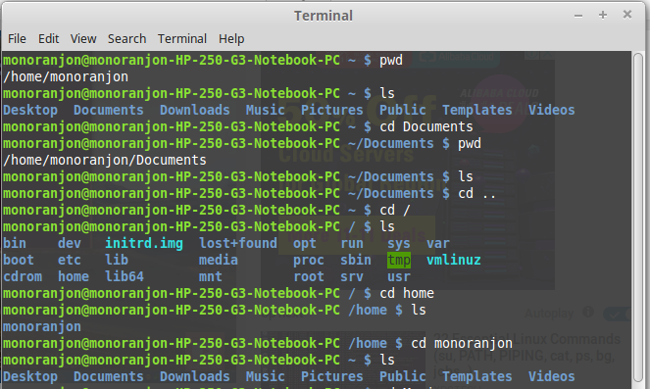

|  |
| --- |
| Working with text editors:  $ rmdir <dir_name> removes entire directory  $ rm <file_name> removes file name |

$ rm ­r < dir_name> removes directory including it's contents  
$ mv <name1> <name2> renames the directories or files  
$ mv <name> <path> moves files/directories to the specified path  
$ cp <name> <path> copies file/directory as specified in path

1. exit         - logout and close terminal  
2. whatis    - display one-line manual page descriptions  
3. clear       - clear the terminal screen  
4. man        - view the local reference manuals  
5. less         - view and search text files

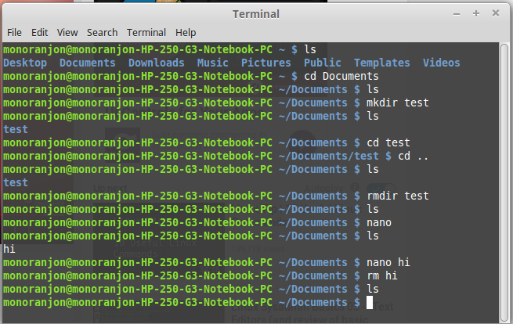

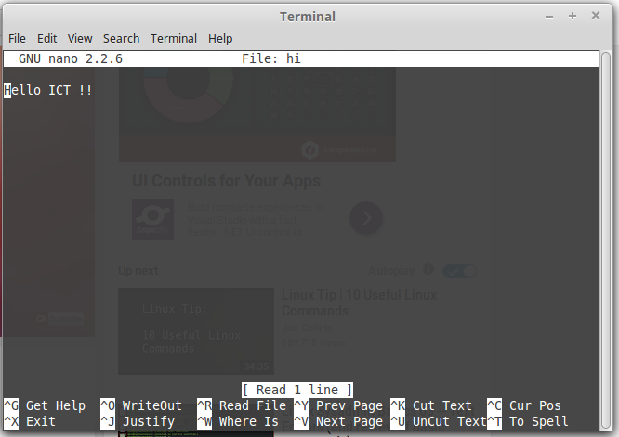

**Conclusion:**

Linux mint is highly secured system. Linux distributions are highly customizable.I have done some basic commands in linux mint.One thing you have to conscious that linux is a case sensitive to perform commands in linux terminal.